Mobile Printing Now Available

Print to the library’s printers from anywhere. Send your documents for printing and come to the library to release and pick them up from the kiosk ($.10 black and white, $.50 color). Mobile Printing is only available on letter size paper – 8.5x11. If you need different sizes, come to the Library.

How to print from a laptop or desktop computer at home or work (outside of the library):
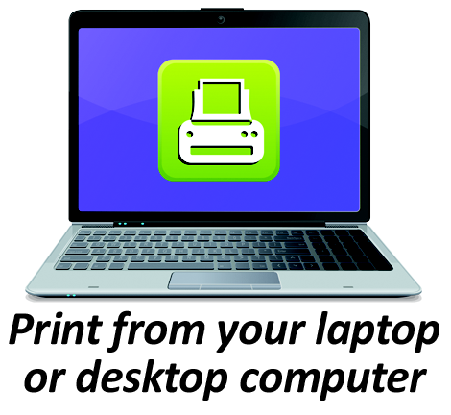
- Begin by visiting www.longviewlibrary.org.
- Click on Mobile Printing
- Click on Web Portal.
- On the new page, select the printer you want – Black and White or Color.
- Enter your email address.
- Browse your computer to find and select the file you wish to print.
- Click the green print icon (you will see the status of your print job and a reference number).
- At the Print Release Station in the library, select “Release a Print Job”.
- Enter the email address you supplied and select your print job.
- Follow the instructions on the screen.
Your print job will be printed!
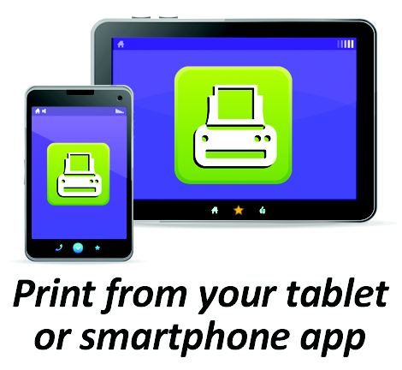
How to print from tablet or smartphone app:

- Download and launch the PrinterOn App.
- Click “No printer selected”.
- Click “Search”. Search for Longview Public Library.
- Find Longview Public Library and click black and white or color and save.
- To print:
  - Documents: when viewing the document, click in the upper right corner and upload the document to the PrinterOn App.
  - Photos from your phone: open the app, click on “photo” and select a photo to print.
  - Select the printer and click the print icon.
  - Enter an email address and click on the check mark (you will receive a notice that the job started, and shortly after another message stating “Job Success”).
  - At the Print Release Station in the library, select “Release a Print Job”.
  - Enter the email address you supplied and select your print job.
  - Follow the instructions on the screen.
Your print job will be printed!

How to use email to send something directly to library print system:

- Email a document as an attachment from any device directly to the library’s print system:
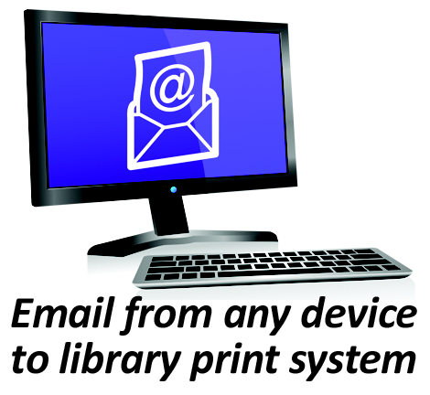
  - For Black and White: lpl-louisiana-st-bw@printspots.com
  - For Color: lpl-louisiana-st-color@printspots.com
- Or – go to www.longviewlibrary.org, select Mobile Printing and click on the link for the correct printer.
- At the Print Release Station in the library, select “Release a Print Job”.
- Enter the email address you used and select your print job (look for the name of the attachment).
- Follow the instructions on the screen.
Your print job will be printed!

